MSU Extension’s Six-Step Community Change Model

Step 6: Reflect and Share What You Learned

Step 6 Guide: Reflect and Share
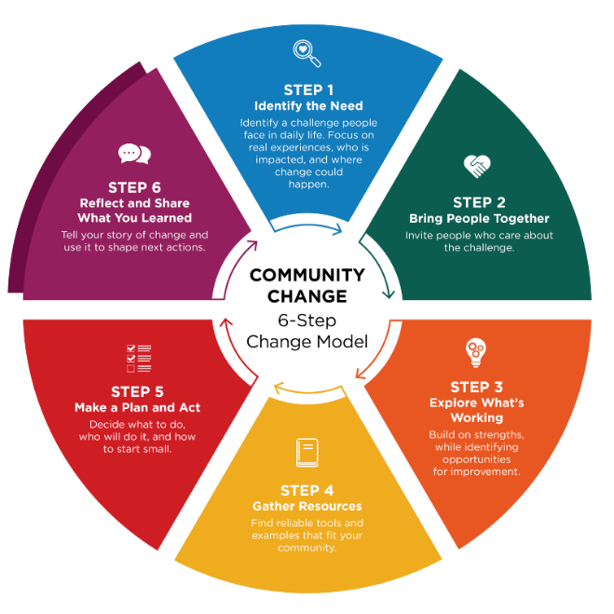
Community Champions often help share the story and celebrate progress.

This step is about looking back and telling the story of what changed. With your team, take time to think about what actions were put into place, what difference those changes made, and what you learned along the way. Taking time to reflect helps everyone see the impact of the work and appreciate the effort it has taken to make the change happen. Reflection can also help you understand what to keep doing, what to adjust, and what new opportunities might exist.

Questions to guide reflection

Ask questions like:
- What changed because of this work?
- How did these changes affect people day to day?
- What worked well, and what was harder than expected?
- What would we do the same — or differently — next time?
- What opportunities does this change open for the future?

These questions help your team understand both the results and the process.

Why reflection matters

Reflection is often skipped, but it is an important part of lasting change. Taking time to acknowledge everyone’s contribution(s) helps people feel valued and keeps them engaged. It also strengthens trust and ownership, which makes it more likely that successful changes will continue. Reflection can also help your group see new needs, ideas, or opportunities to explore next.

Share your story

Highlighting accomplishments with the wider community can build interest and support for future efforts. Sharing your story helps others see what is possible — and may inspire them to get involved.

Step 6 Worksheet: Reflect and Share

Track and reflect on what changed and how to keep success alive. Community Champions help tell the story and celebrate progress.

Success tracking

Goal: ____________________________________________________________________________

What has changed in the community because of our work? What did you try, and how did it go? ______________________________________________________________________________________________________________________________________________________________________________________________________________________________________________________

What felt easy? ______________________________________________________________________________________________________________________________________________________________________________________________________________________________________________________

What felt challenging?
______________________________________________________________________________________________________________________________________________________________________________________________________________________________________________________

Community champion contribution

- Community Champion helped sustain participation
- Community Champion helped navigate setbacks
- Community Champion helped tell the story and celebrate wins

What is ONE sign it worked?

Choose all that apply:
- Participation increases
- Daily routines feel smoother / fewer problems come up
- Staff report it feels easier or more supported
- Participants/families report benefits
- More consistent implementation across staff/site
- Other: _______________________________________________________________________

Success Tracking

Tracking Question | Gathering Information | Summarizing | Reflection
What success have you had? | Participation records, surveys, observations | How many people attended? What changed? | What worked and why? What still needs attention and improvement?
What will you do next?

Choose all that apply:
- Keep it going
- Adjust and continue
- Expand to other settings/groups
- Pause/stop and try something different
- Next step(s): ____________________________________________________________________

What will make it easier to continue and keep this success alive?

Choose 1-2:
- Build it into an existing routine or schedule
- Assign clear ownership (person/team)
- Create a simple checklist or system
- Communicate reminders
- Add signage or visual cues
- Improve access to needed supplies/space
- Other: ________________________________________________________________________
- How we will monitor: _____________________________________________________________

Who could benefit from hearing this? Share what you learned (keep it simple).

- Staff/team
- Leadership
- Families
- Participants
- Community partners
- Other: _________________________________________________________________________

How will you share?

Choose all that apply:
- Quick email
- Brief staff update
- Conversation
- Posting/signage
- Newsletter/social media
- Other: _________________________________________________________________________

About MSU Extension’s Community Change Model
This Guide and Worksheet is part of a larger Six-Step Community Change Model Toolkit that assists community champions in supporting communities to make thoughtful, lasting improvements that help people choose nourishing foods and stay active. Six simple steps guide desired change efforts by bringing people together, taking action, and sharing what was learned along the way.
See MSU Extension’s Community Change Hub for curated resources and topic-specific guidance that support change efforts related to championing school wellness, food access, early childhood health, and active communities.

